**2015 US Open Grand Prix Gold: Manu Attri and B.Sumeeth Reddy in Finals**

[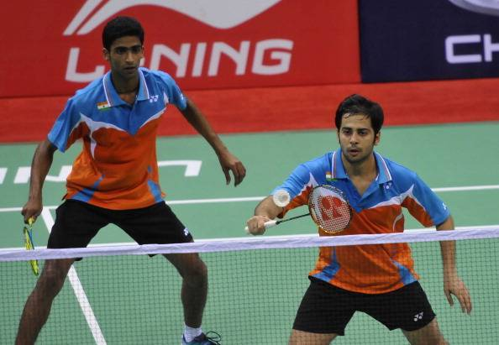](http://static.sportskeeda.com/wp-content/uploads/2015/06/manu-attri-reddy-1434868001-800.jpg)

**(Manu Attri and B.Sumeeth Reddy will play in the finals on Sunday)**

**New York: Good news for the Indian Badminton lovers came from the Men’s Doubles section where the young and extremely talented pair of Manu Attri and B. Sumeeth Reddy kicked out the 4th seeds Japanese to progress through to the final two of the tournament.**

**World ranked 26,  Attri and Reddy, who defeated the 2nd seeds in the second round caused another upset as they stunned the 4th seeded Japanese pair of Takeshi Kamura and Keigo Sonoda 21-17 21-17 in the Semifinals.**

Indian pair started aggressively as they opened up to a 8-3 lead in the first game. From 9-5 up, Attri and Reddy clinched the next four points in a row to further stretch their advantage. With such a huge lead, they faced absolutely no difficulty in closing the game 21-17.

Second game saw a situation reversal as this time the World ranked 22 Japanese pair took a five point advantage at the mid game interval. But the Indian pair made a remarkable comeback to win 8 out of the next 11 points to back level the scores to 14-14. It was at this point that the Indians shifted their gear to roll the next few points in quick succession to draw the curtains on the challenge of the Japanese pair.

They will now take on the World ranked. 29 Chinese pair of Junhui Li and Yuchen Liu in the summit clash.

×Close

**Report Errors**

Use this window to let us know of any feedback about the content.



Submit

|  |
| --- |
|  |

On day five the experienced pair of Jwala Gutta and Ashwini Ponappa were knocked out in the Semifinals of the Yonex Suffolk County Community College US Open Grand Prix Gold Tournament. Jwala Gutta and Ashwini Ponappa lost to the World ranked 39 Japanese pair of Ayane Kurihara and Naru Shinoya by a scoreline of 17-21 11-21.

B. Sai Praneeth also suffered a one sided defeat to former World No. 1 Lee Chong Wei. 16th seed and World ranked 38th B. Sai Praneeth went down to former World No. 1 Malaysian Badminton star Lee Chong Wei in the last four of the tournament. Lee Chong Wei, who is playing his first Open Tournament title after serving an eight-month ban over a doping violation bulldozed past the Indian shuttler 21-9 21-17 in 34 minutes, to reach the finals of the men’s singles category.

The 33-year-old player, who is cuurently ranked 180 will now take on the 3rd seed and World ranked 18 Danish shuttler Hans-Kristian Vittinghus in the Championship match.

---------------------------------------------